PROJECT REPORT

ON

“Dream Wash”

(E-Service Center)



SAVITRIBAI PHULE PUNE UNIVERSITY

MASTERS OF COMPUTER APPLICATION

M.C.E. SOCIETY’S

ALLANA INSTITUTE OF MANAGEMENT SCIENCES, PUNE

2018-2019

DECLARATION

We hereby declare that the project work entitled “Dream Wash” submitted to the Savitribai Phule Pune University, Pune, is a record of an original work done by us and this project work is submitted in the partial fulfillment of the requirements for the award of the degree of Master of Computer Application. The project work in this report has not been submitted to any other University or Institute for the award of any degree or diploma.

As authors of this Group Project report, entitled “Dream Wash” our signatures on the document signify our joint responsibility in this project.

Sr. | Roll | Name of Student | Functionality/ Module | Sign
No. | No.
1. | 39 | Pawan Chintala (TL) | Customer Dashboard
2. | 37 | Muqarril Ansari | Employee Dashboard
3. | 21 | Ibrahim Kumbahar | Login/Signup/Forgot Password
4. | 61 | Zaid Shaikh | Admin Dashboard

This Group Project Report is authored by Allana Institute of Management Sciences’ students and has been reviewed and approved by:

Mr. Tajuddin Bennur,

Sign__________________________

CERTIFICATE OF THE GUIDE

CERTIFIED that the work incorporated in the project entitled “Dream Wash” submitted by,

Mr. Pawan Chintala

Mr. Muqarril Ansari

Mr. Ibrahim Kumbhar

Mr. Zaid Shaikh

was carried out by the candidate under my guidance.

Date:

Mr. Tajuddin Bennur

(Project Guide)

ACKNOWLEDGEMENT

I would like to convey my sincere gratitude to all those who have been instrumental in the development of the project.

I am greatly thankful to honorable Dr. Prof. R. Ganesan, Director of Allana Institute of Management Sciences, Azam Campus for all his timely support.

I express my gratitude to the Head of MCA Department Dr. Shaikh Ashfak who helped me in my extreme solutions.

I am also thankful to Mr. Tajuddin Bennur, my internal project guide for his invaluable guidance, help and great support during the project work.

I am greatly thankful to the staff of Allana Institute of Management Sciences, Pune for helping me through the entire course.

- Mr. Pawan Chintala(TL)

- Mr. Muqarril Ansari

- Mr. Ibrahim Kumbhar

- Mr. Zaid Shaikh

Table of Contents

Sr. No. | Topic | Page No.
CHAPTER 1 | INTRODUCTION
1.1 | Existing System and Need for System | 1
1.2 | Operating Environment - Hardware and Software | 1
1.3 | Description of Technology Used | 2

CHAPTER 2 | PROPOSED SYSTEM
2.1 | Proposed System | 3
2.2 | Objectives of System | 3
CHAPTER 3 ANALYSIS & DESIGN
3.1 | Class Diagram | 4
3.2 | Use Case Diagrams | 5-6
3.3 | User Interface Design (Screens etc.) | 7-18
3.4 | Table specifications ( in case back end is a database ) | 19-22
CHAPTER 4 | Drawbacks and Limitations | 23
CHAPTER 5 | Proposed Enhancements | 24
CHAPTER 6 | Bibliography | 25

INTRODUCTION

Existing System and Need for System:-

An open bay (the area that the car sits inside) is typically used in these systems. Previously, the customers have to take their own cars to the garage to wash their cars. Which was a big hassle for the customer to drive a long distance from their home to wash their cars. To avoid such hassle for the customers , we have made an online system wherein a customer don’t have going to the garage to wash their cars. This System is design in a way,where the customer can book an appointment and once the appointment is confirmed ,the particular employee which is assign to complete the task ,will come and will do the respective work accordingly in a given time frame

Hardware Requirements:-
➢ System |  |  | :Dual Core 2.4 GHZ.
➢ Hard Disk |  |  | :5GB Onwards.
➢ Ram |  |  | :512 Mb.
Software Requirements:-

➢ Operating System :Windows 7/8.1/10,Linux

➢ Coding Language :PHP (7.2.7)

➢ Database :mysql (10.1.34-MariaDB)

1

Description of Technology Used:-

1. Browsers

Browsers are the interpreters of the web. They request information and then when they receive it, they show us on the page in a format we can see and understand.

  - Google Chrome - Currently, the most popular browser brought to you by Google
  - Firefox - Open-source browser supported by the Mozilla Foundation

  - Internet Explorer - Microsoft’s browser. You will most often hear w complain about this one.

- HTML

HTML is a markup language. It provides the structure of a website so that web browsers know what to show.

3. CSS

CSS is a Cascading Style Sheet. CSS let’s web designers change and transitions on the web. They make the web look good.

- Programming Languages

  - Javascript - used by all web browsers, Meteor, and lots of other frameworks
  - PHP - used by Wordpress
PHP (7.2.7)

- Databases

Databases are where all your data is stored. It’s like a bunch filled with files. Databases come mainly in two flavors: SQL and NoSQL. SQL provides

more structure which helps with making sure all the data is correct and validated. NoSQL provides a lot of flexibility for building and maintaining applications.

- MySQL - is another popular open-sourced SQL database. MySQL is used in Wordpress
websites.

10.1.34-MariaDB

2

PROPOSED SYSTEM

Proposed System:-

The proposed system has better both I/O capabilities of each user skills while interacting with the system. The retrieval of the records in much faster than the Existing System. Hence it cause to saving user time for the further work. The user can buy a package of his/her convenient choice and then book an appointment for the car wash. The user will also go through the option of payment details to book an appointment for the car wash.

The user can buy package and then have to go through the process of taking an appointment for the car wash. Once the appointment is confirmed, the particular employee which is assign to complete the respective task, will come and will wash the car in the time which the customer have selected at the time of appointment.

Once the task is completed, the status will reflect as completed. This will reduce time and the user will not go through the issue of travelling to the car wash center to wash a particular car.

Objectives of Proposed System:-

- Speed

- Reduction of data redundancies

- Increase in performance

- Reducing the process time

3

ANALYSIS & DESIGN

Class Diagram:-
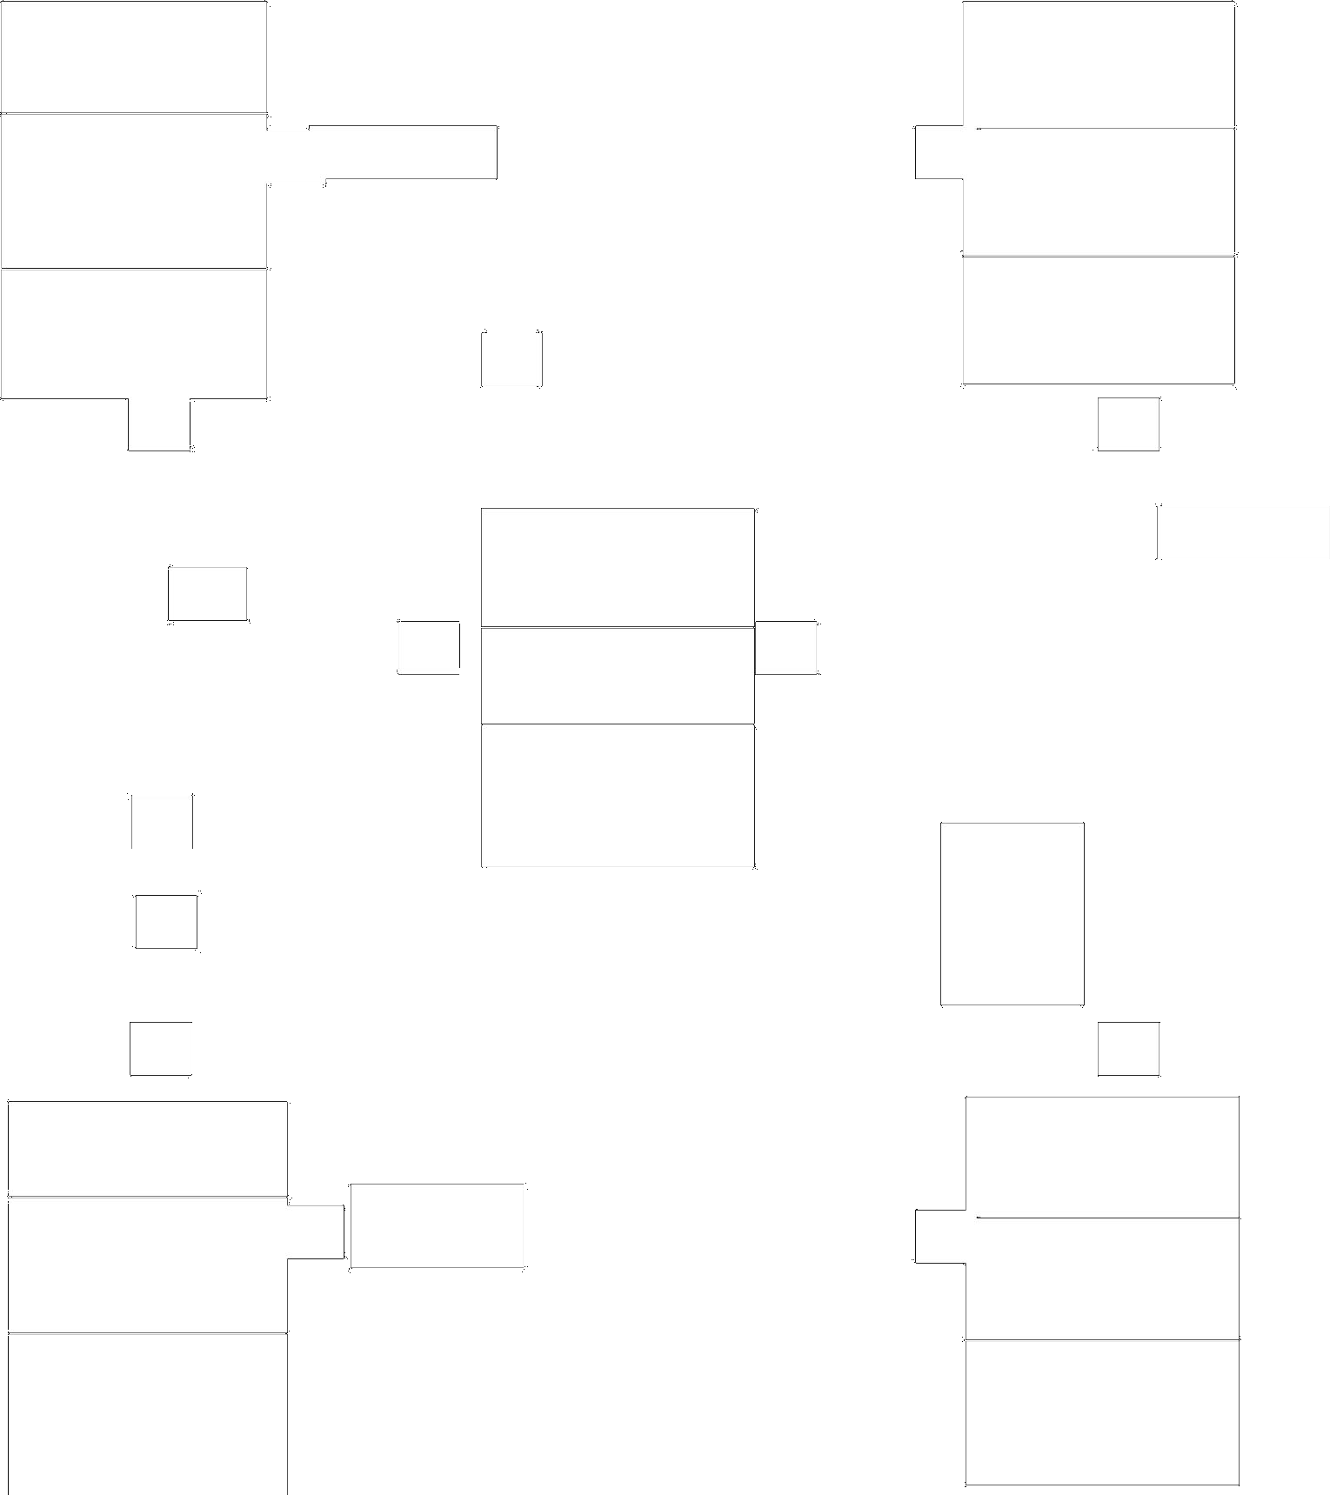


Customer

varchar[20] email;

varchar[20] password;

varchar[20] mobile;

Customer_addrs();

Customer_sign();

1

Order

1

Buy

1-M

 |  |  |  | Employee
_{1-M} Provide Service |  | 1
_{1-M} Provide Service |  |  |  | int empid;
 |  |  |  | varchar[20] name;
 |  |  |  | employeedetail();
 |  |  |  | AppointmentDetail();
 |  |  |  | 1-M
 |  |  |  | Give
 | Appointment |  |  | appointment
1-M |  |  | 1-M
1-M | int Aid; |  | 1-M

varchar c_name;

Appointdetail();

package();

Customerdetail();

handle

1

Package |  |  |  | Admin
 | 1-M | create/update
int package_id; | 1-M | create/update | 1
 |  |  |  | int Admin_id;
varchar packagename; |  |  |  | varchar[20] name;
payment();
 |  |  |  | Admindetai();
package_Detail(); |  |  | 4

Use Case Diagrams:-
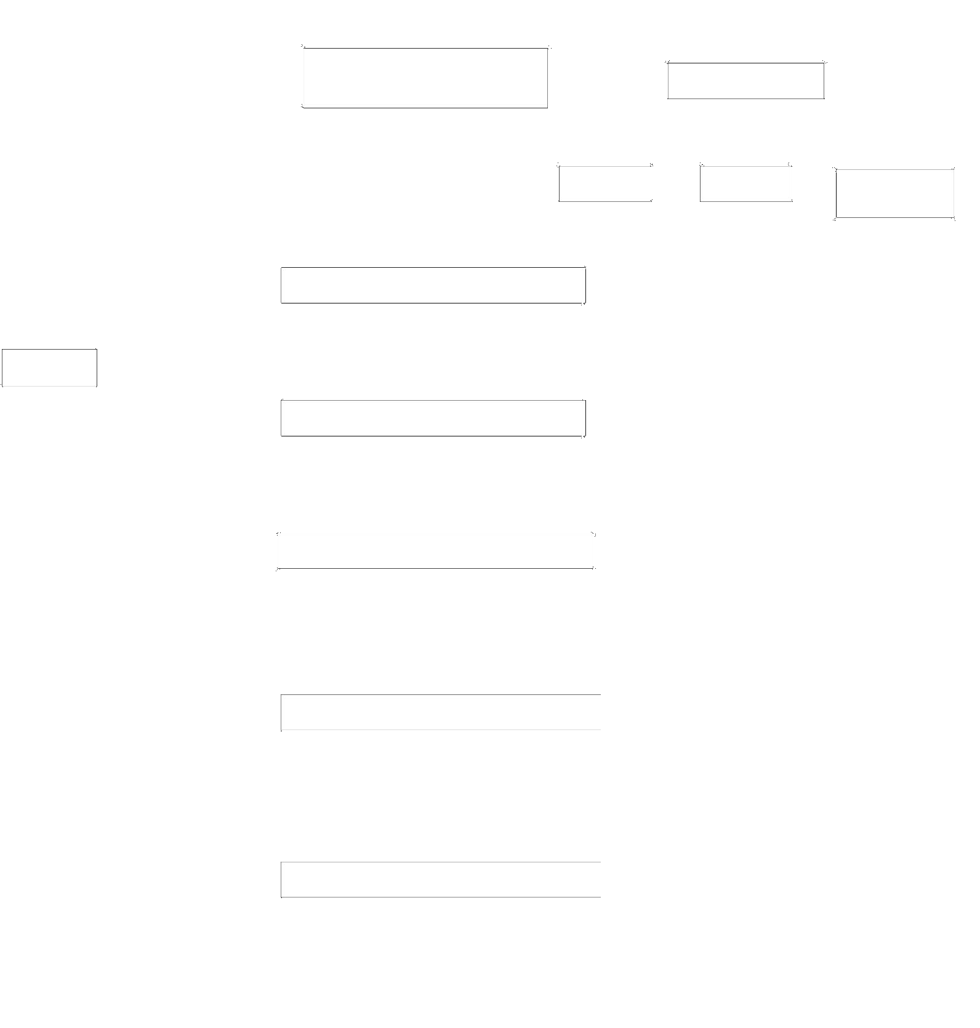
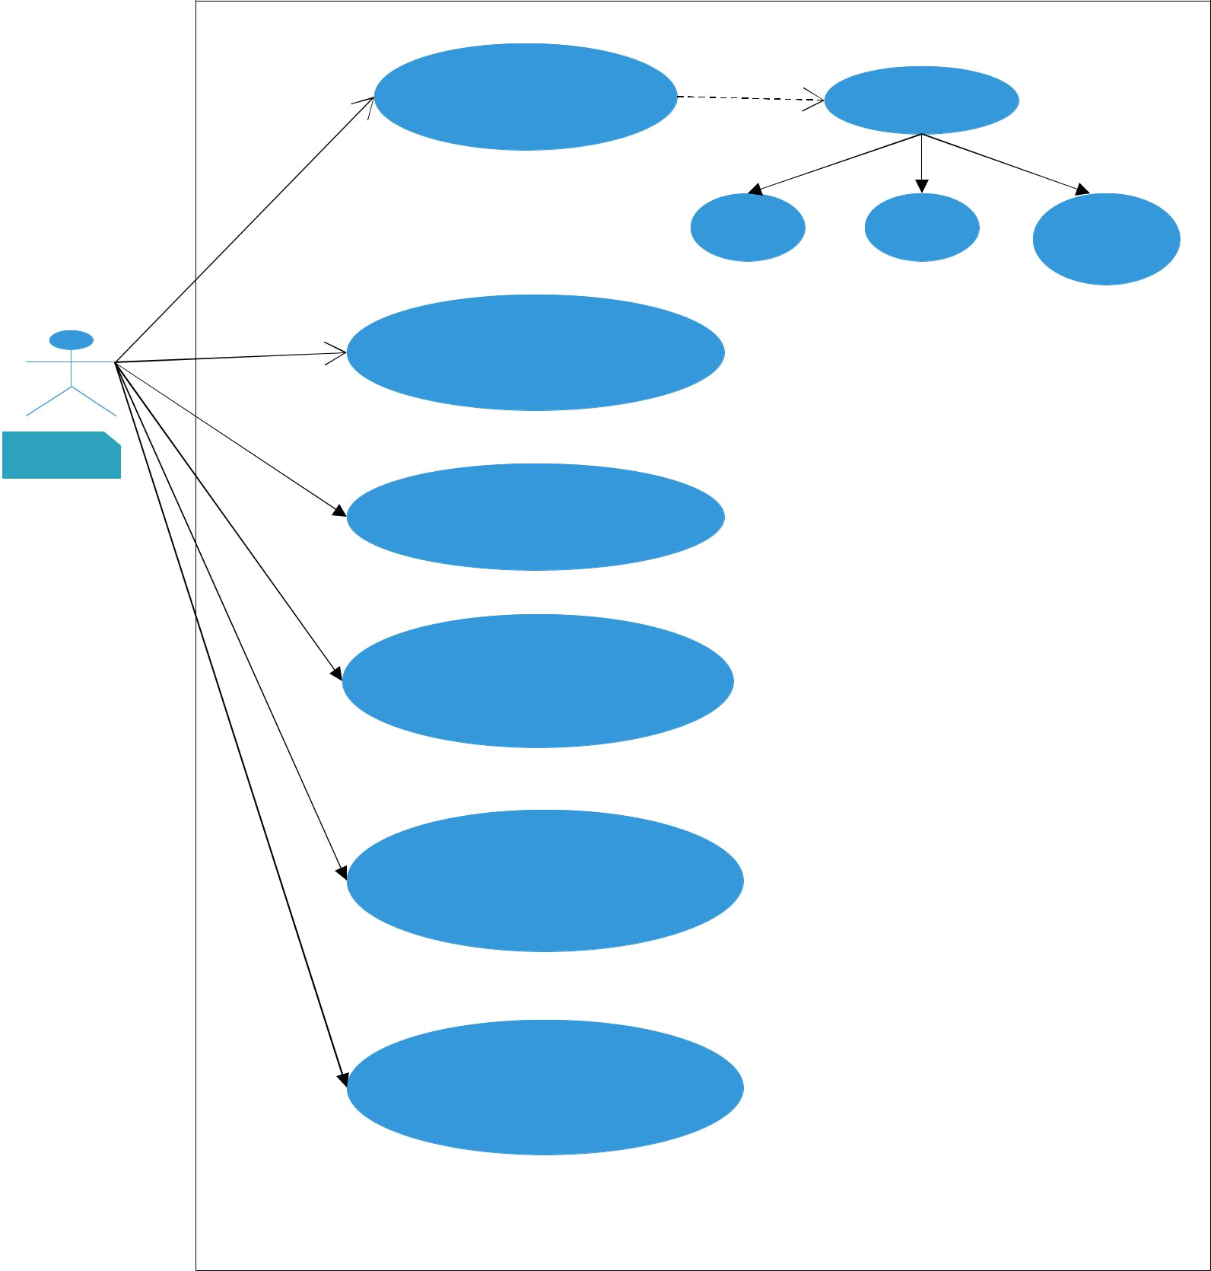

login
Registration

Name | Address | Mobile
 |  | Number

Book Appointment

Customer

Select Packages

Makes Payment

Gives Feedback

View History

5

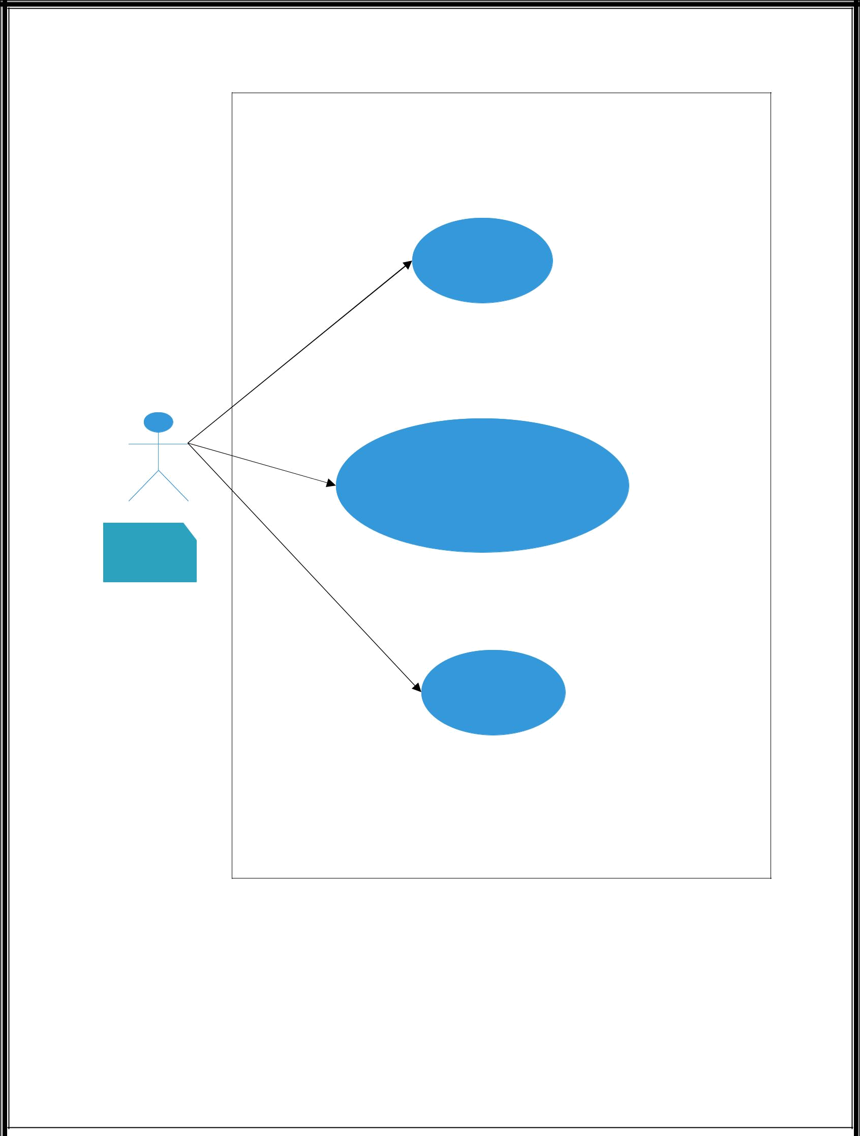

Login

Get the customer Details

Employees

Complete Tasks

6

User Interface Design:-

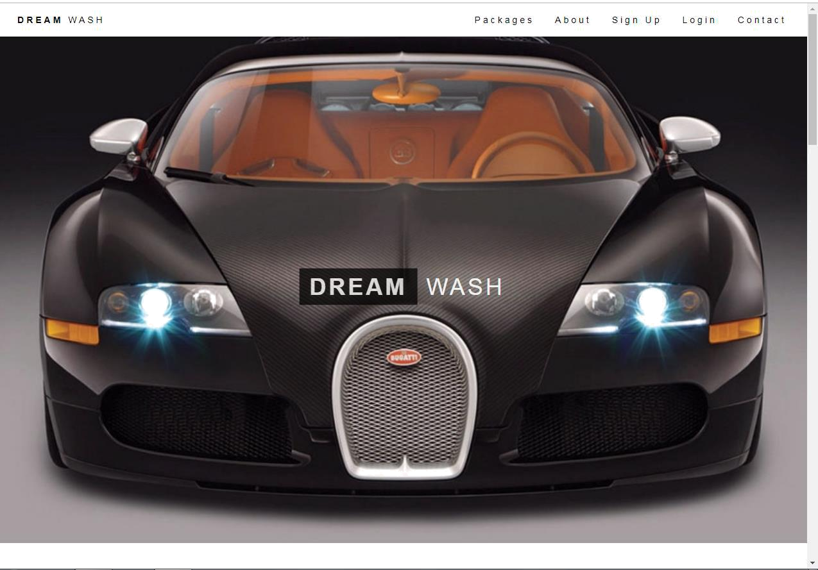

7

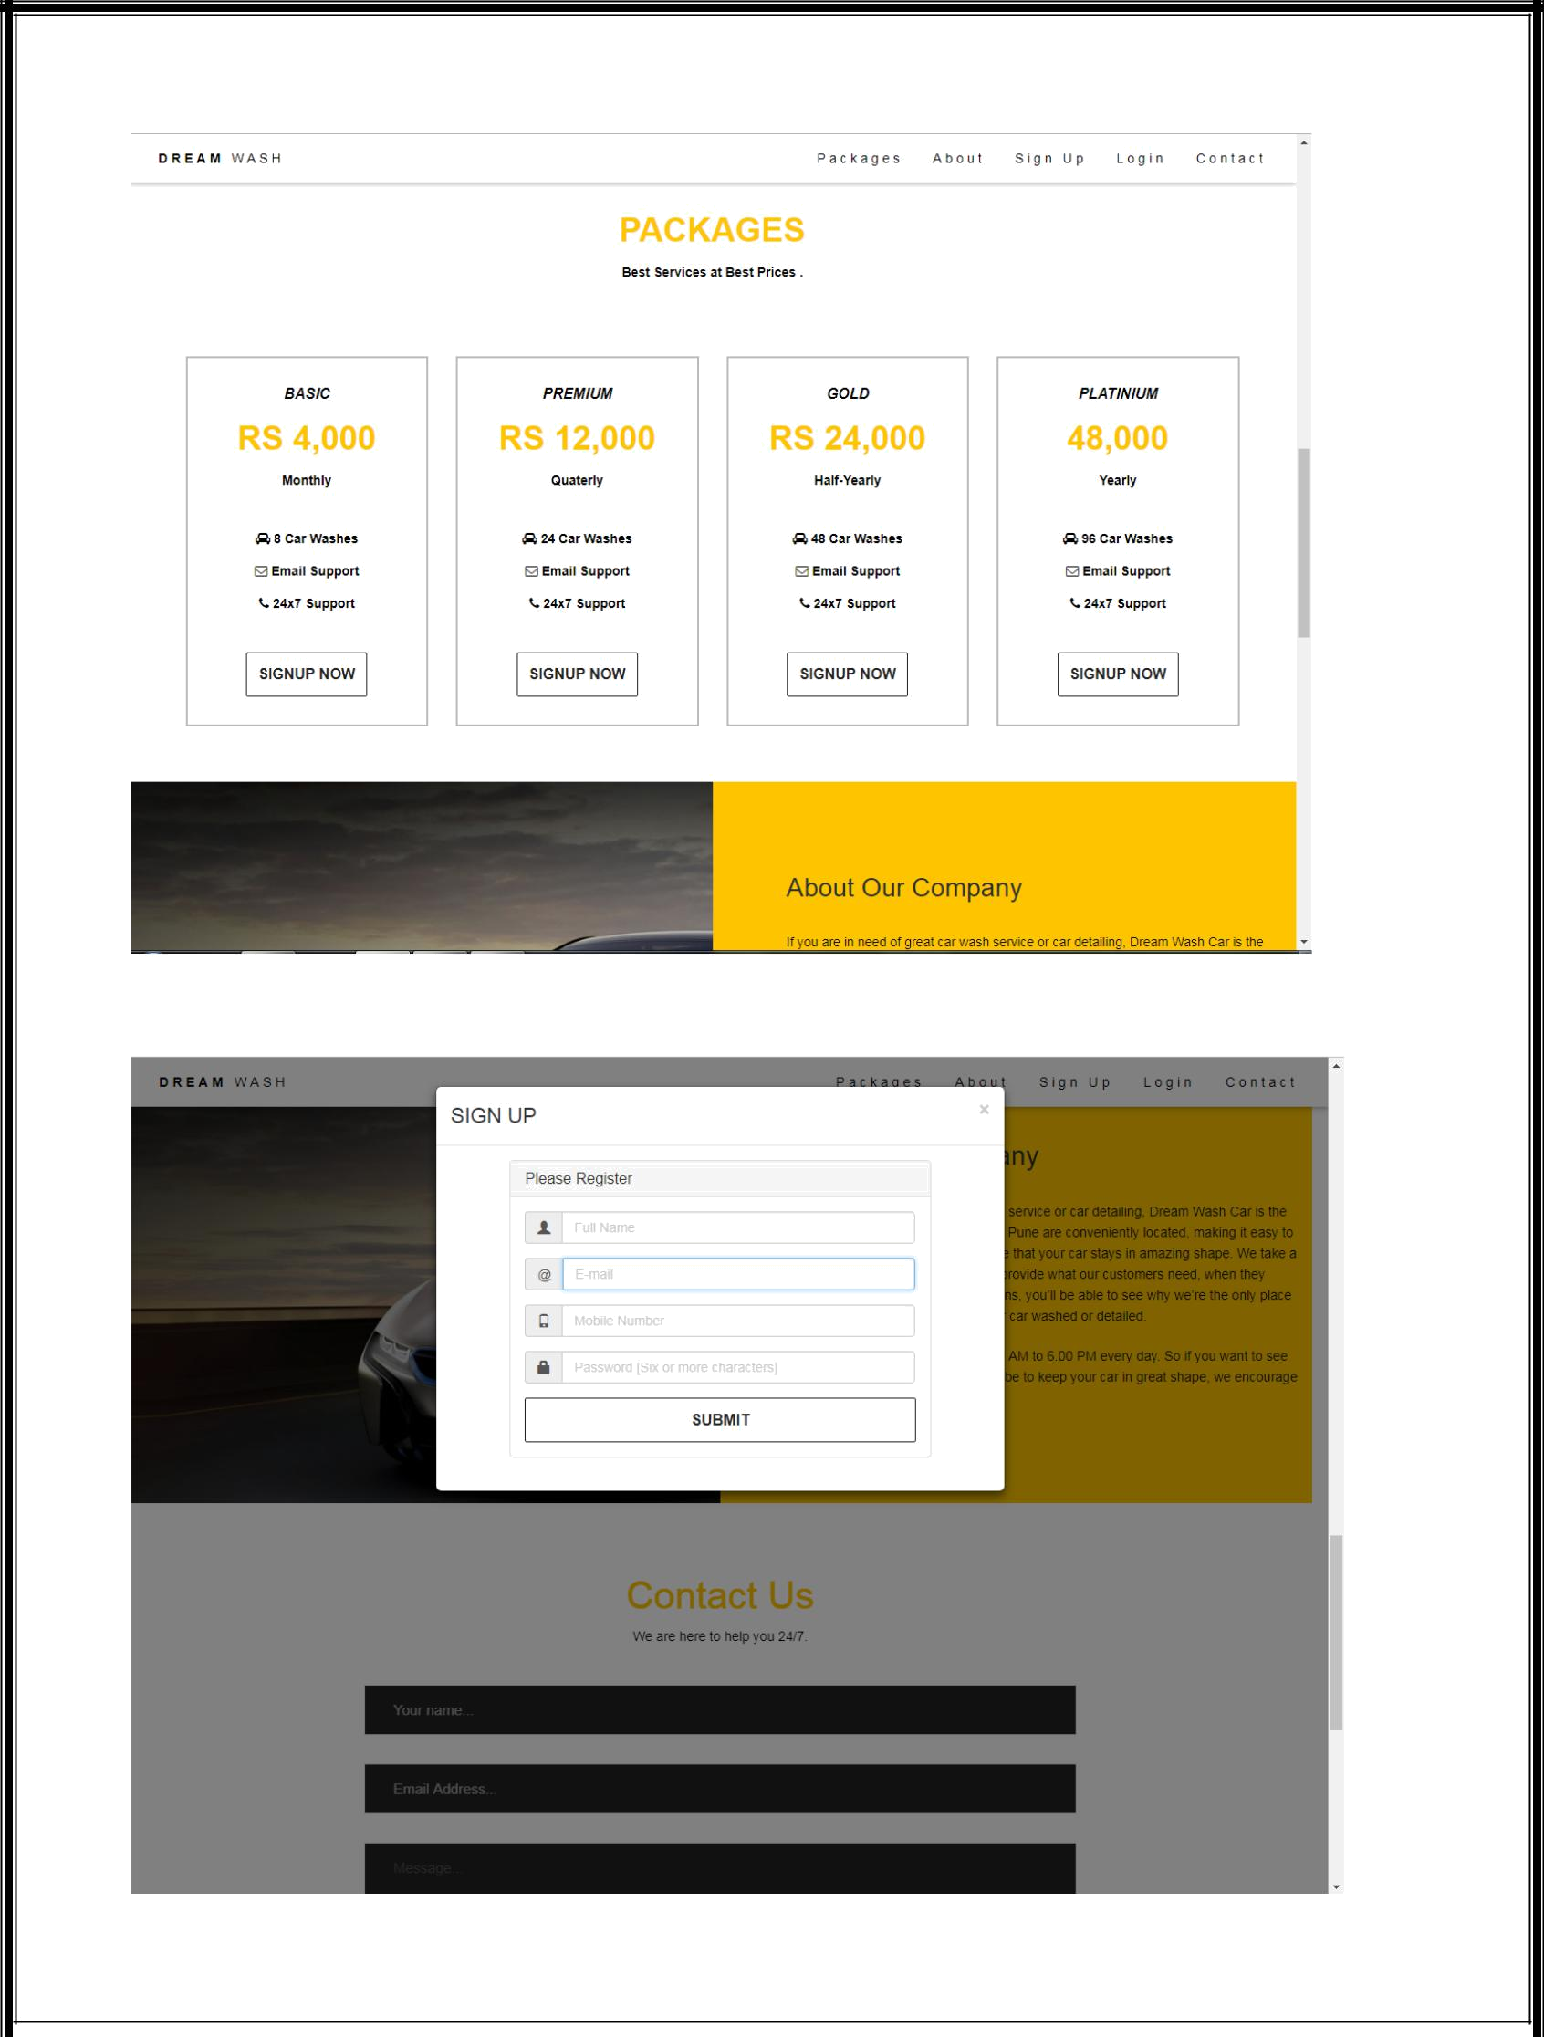

8

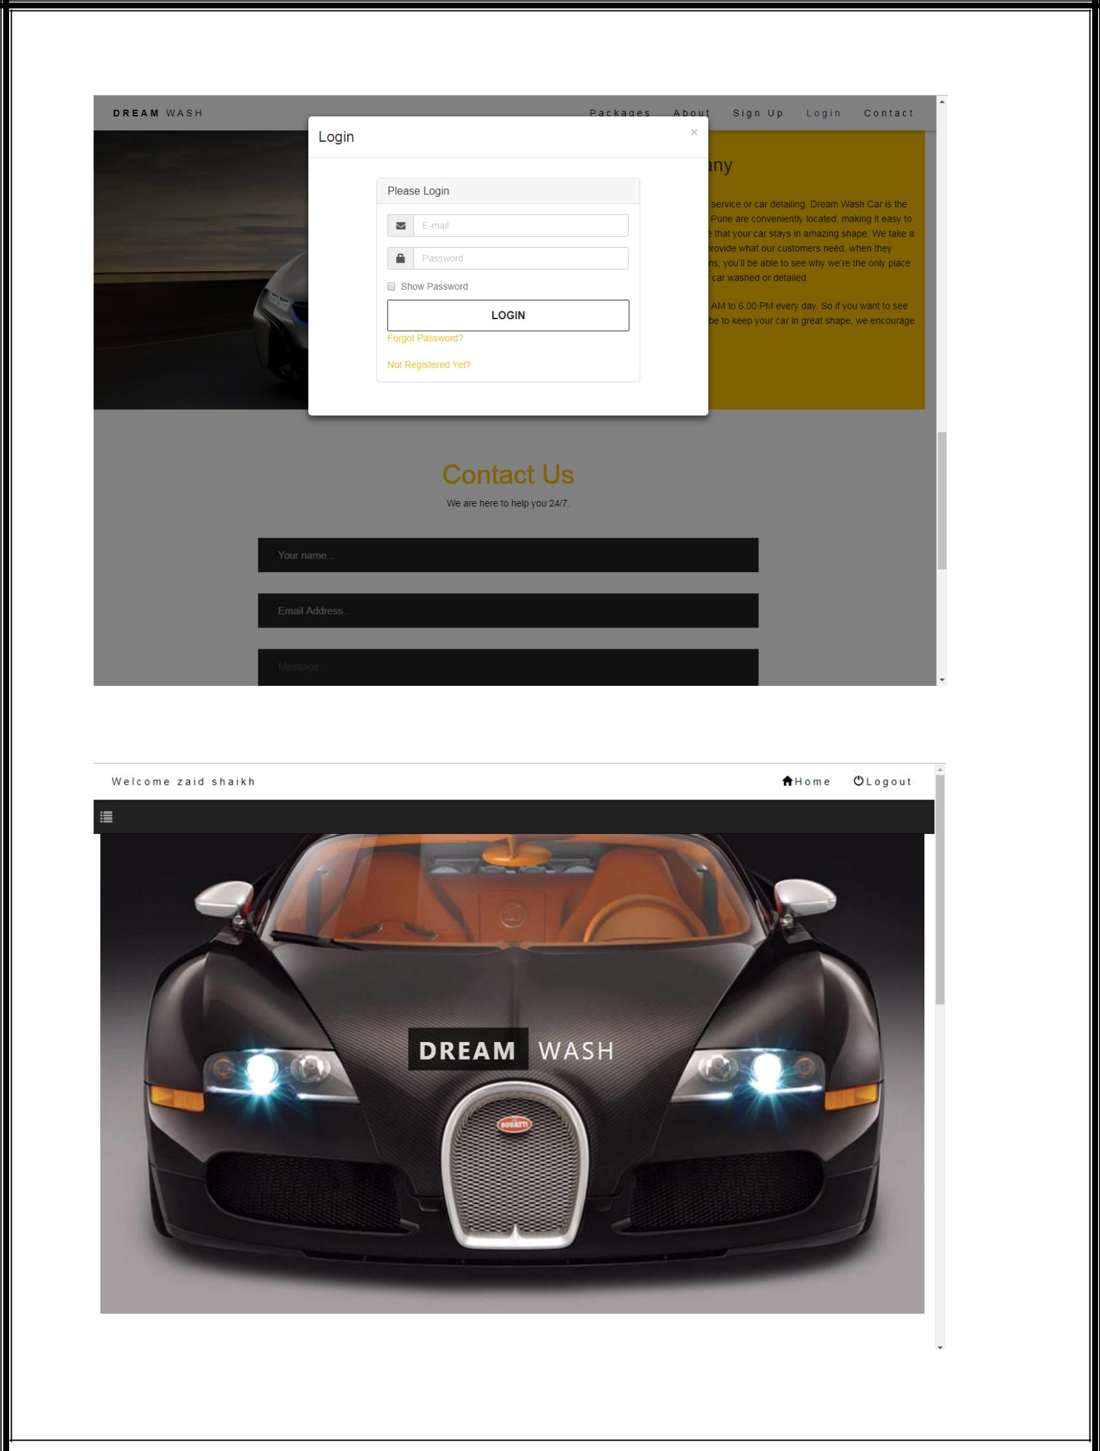

9

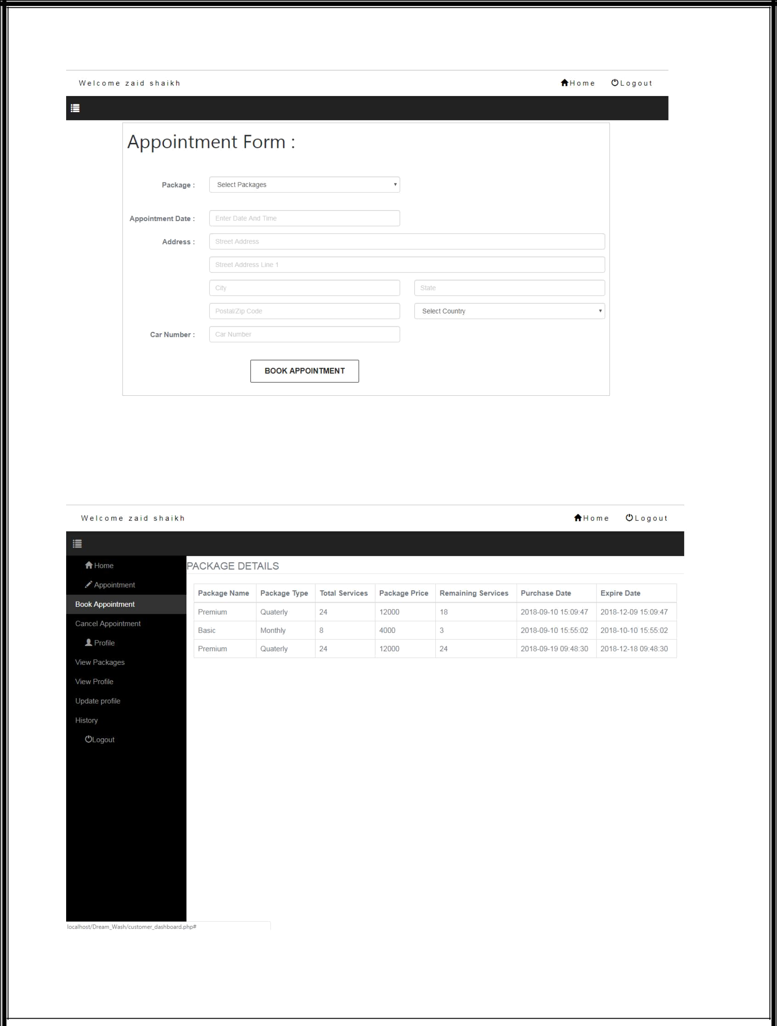

10

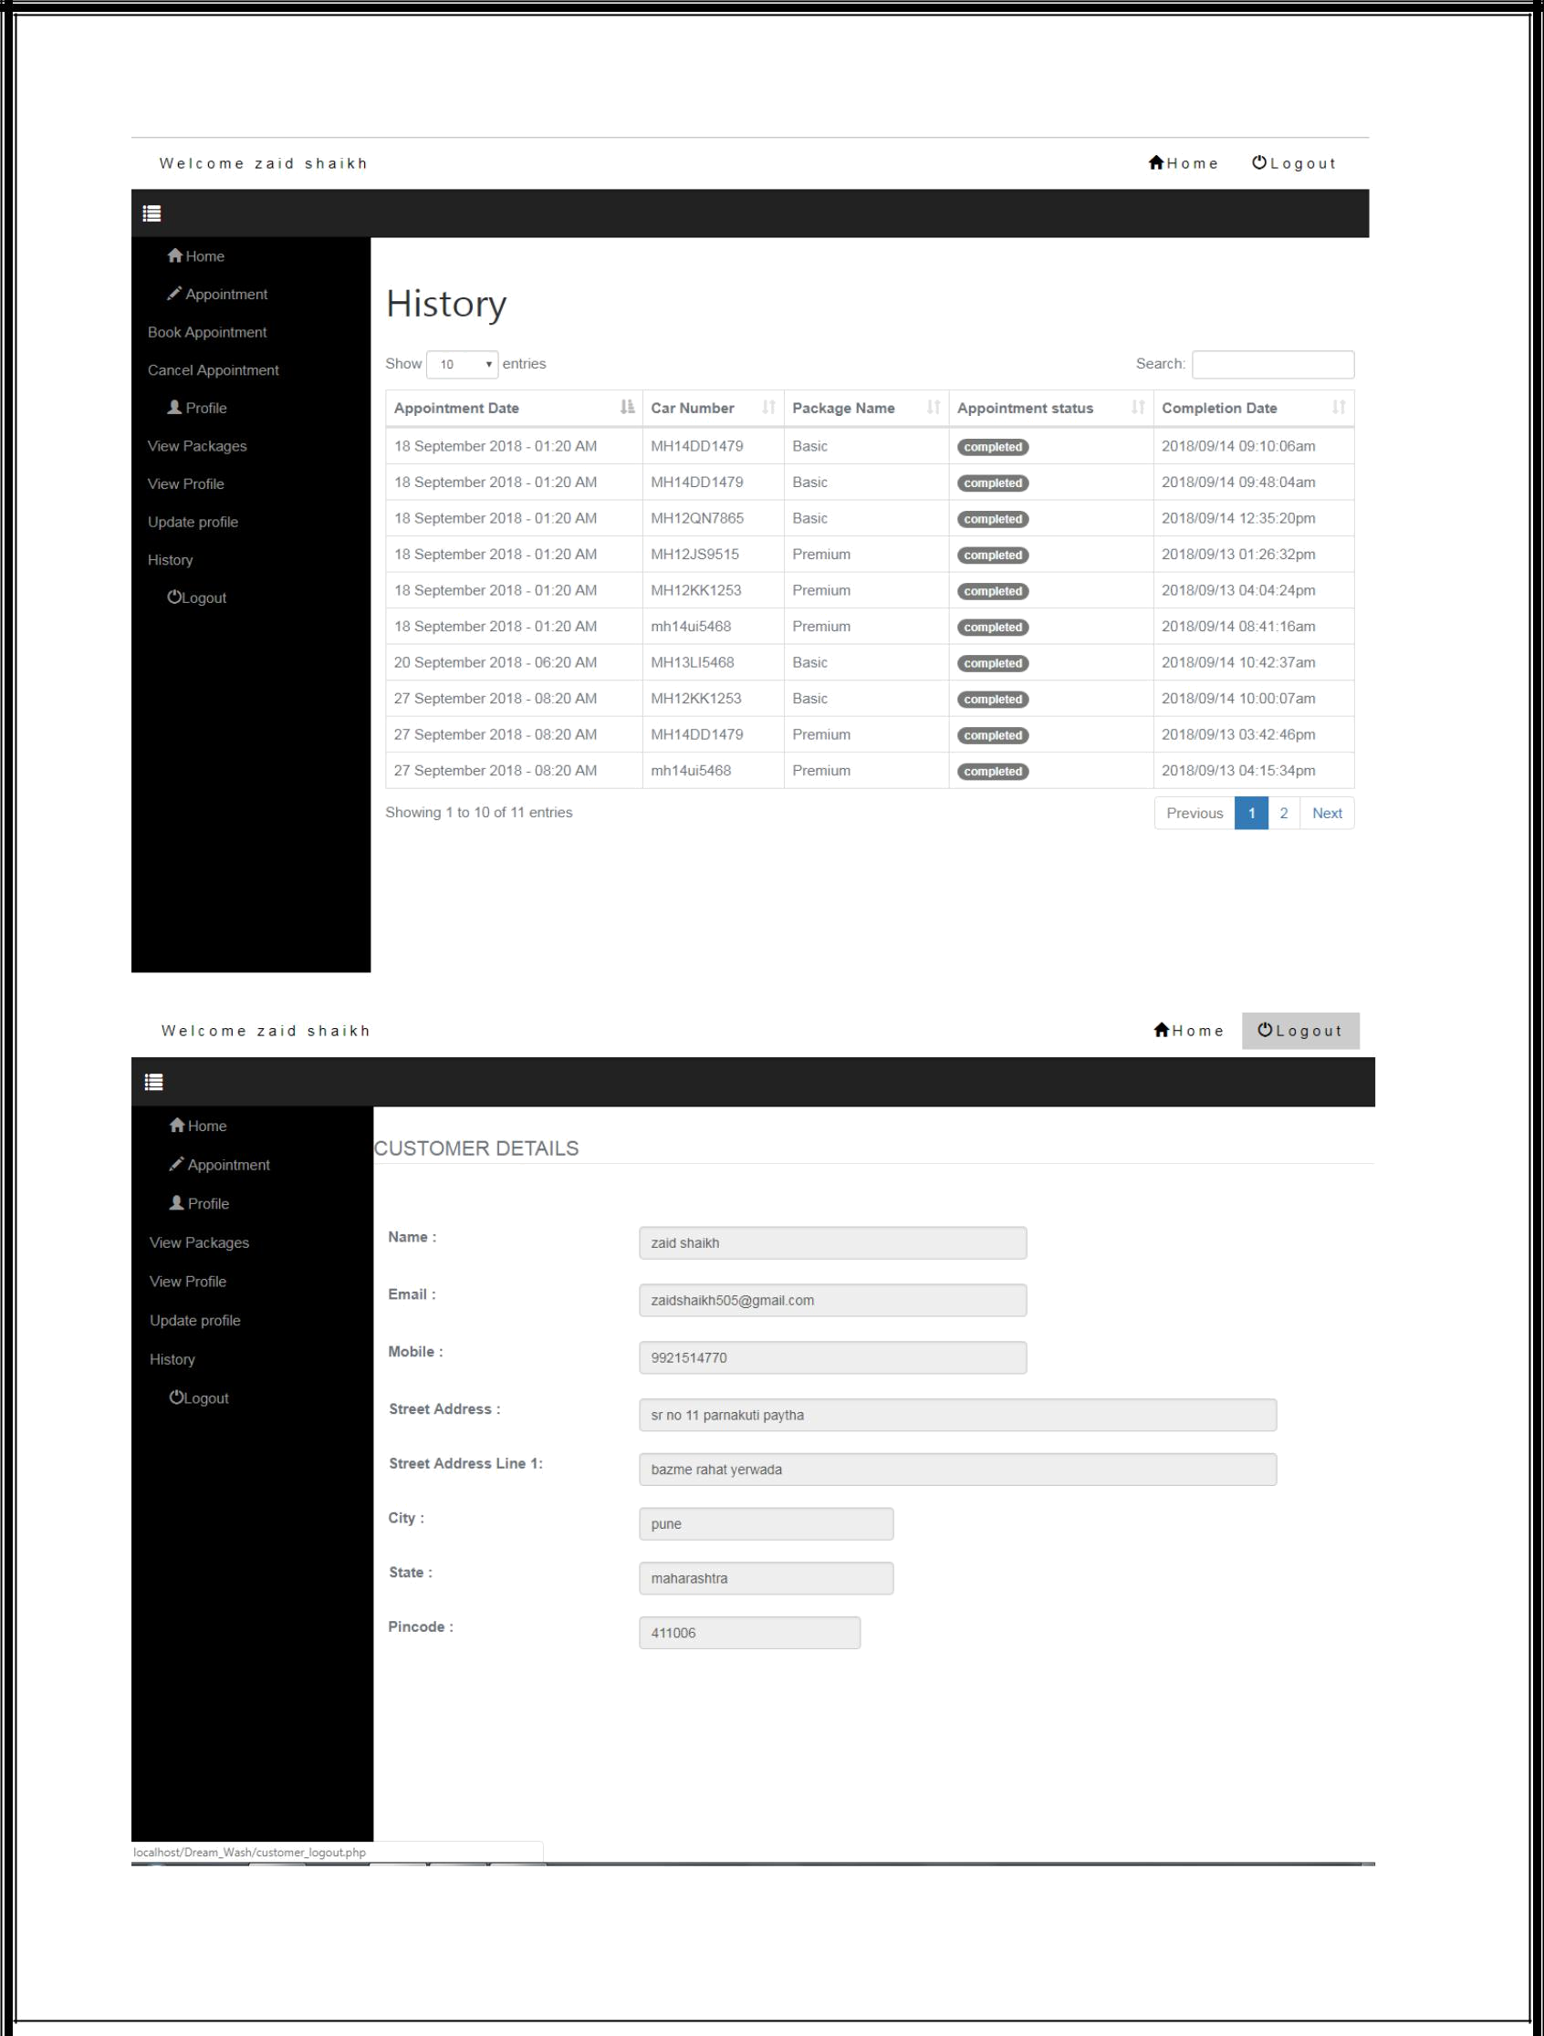

11

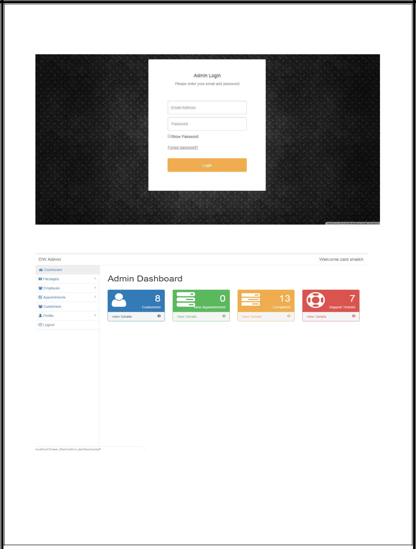

12

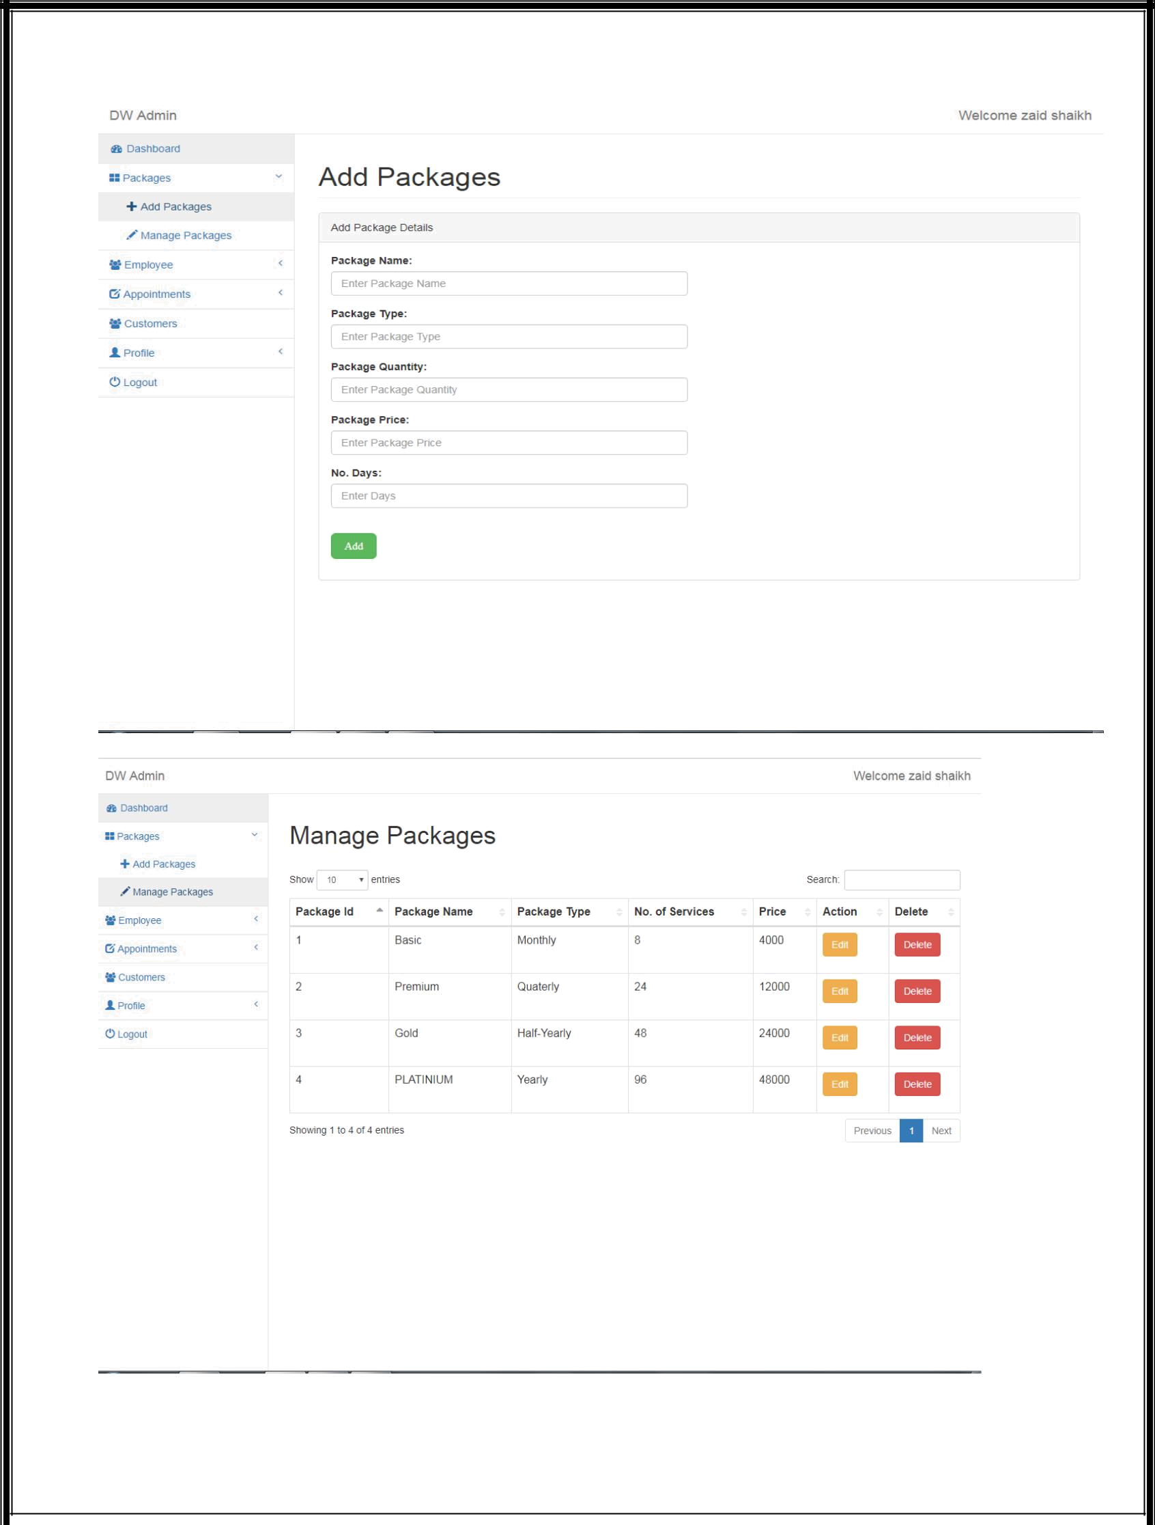

13

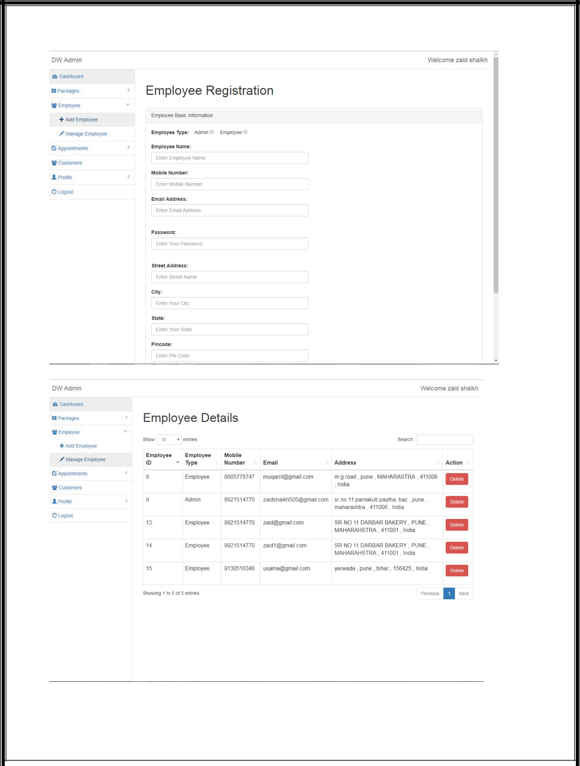

14

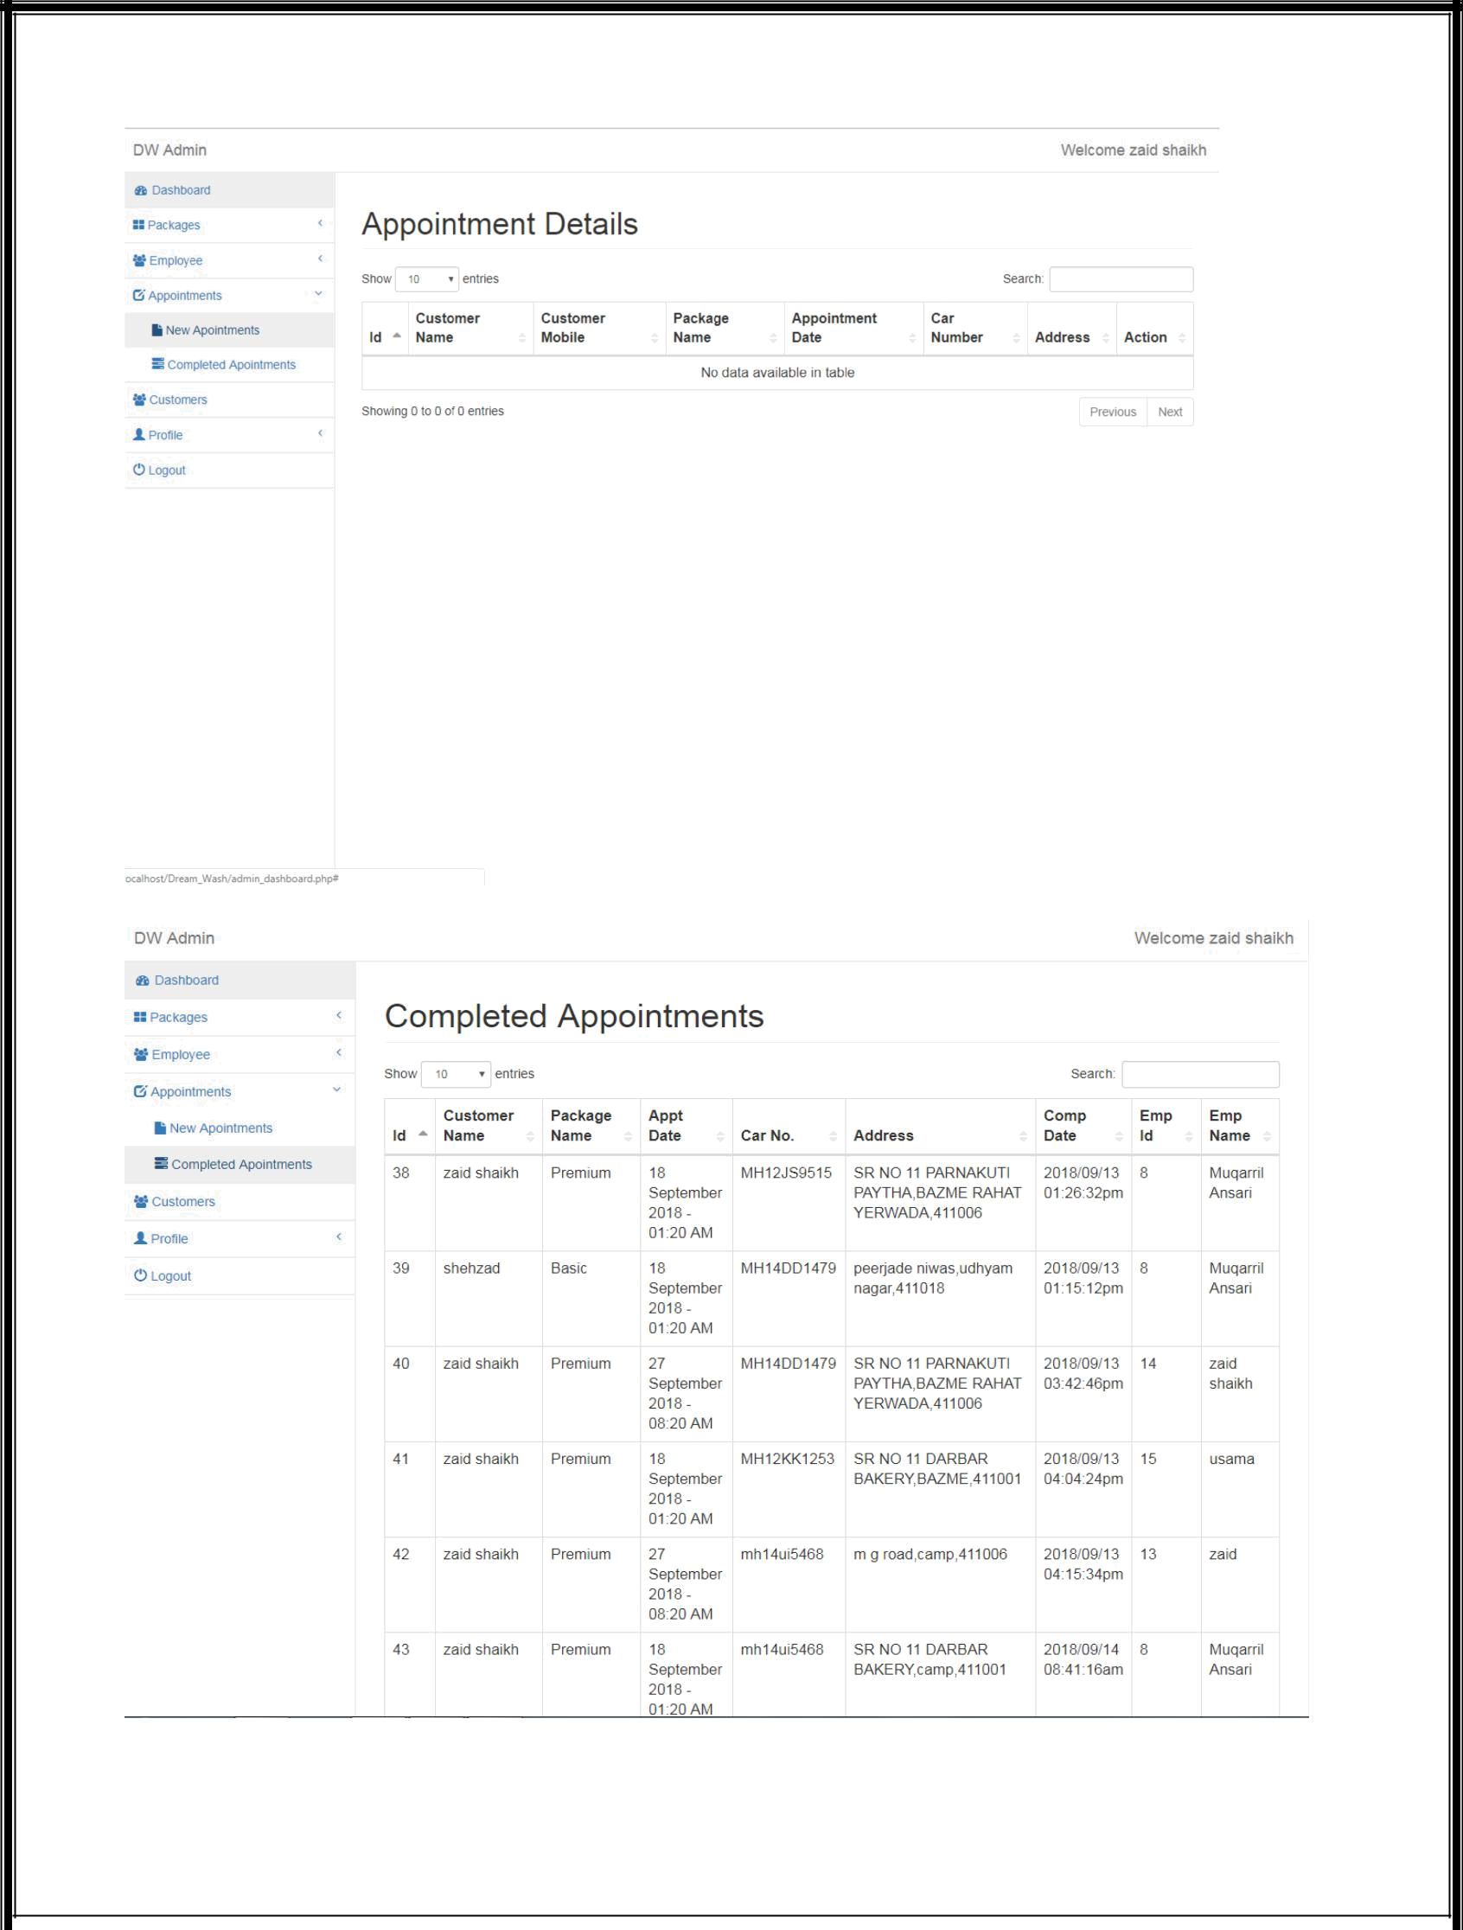

15

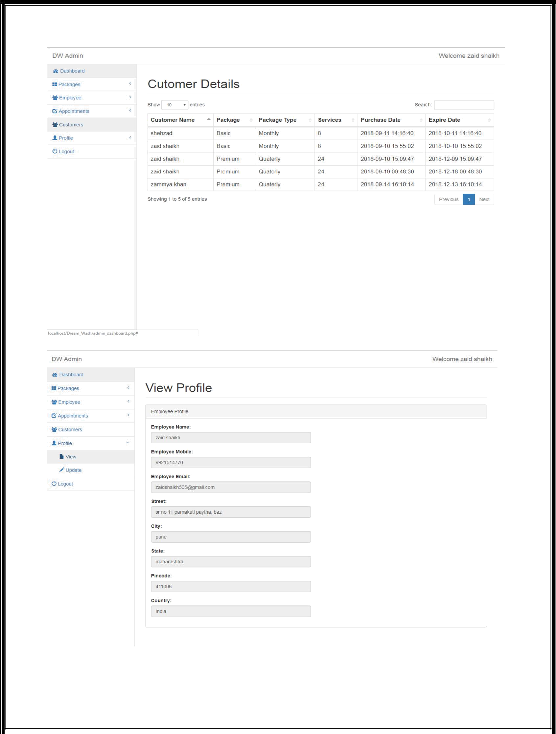

16

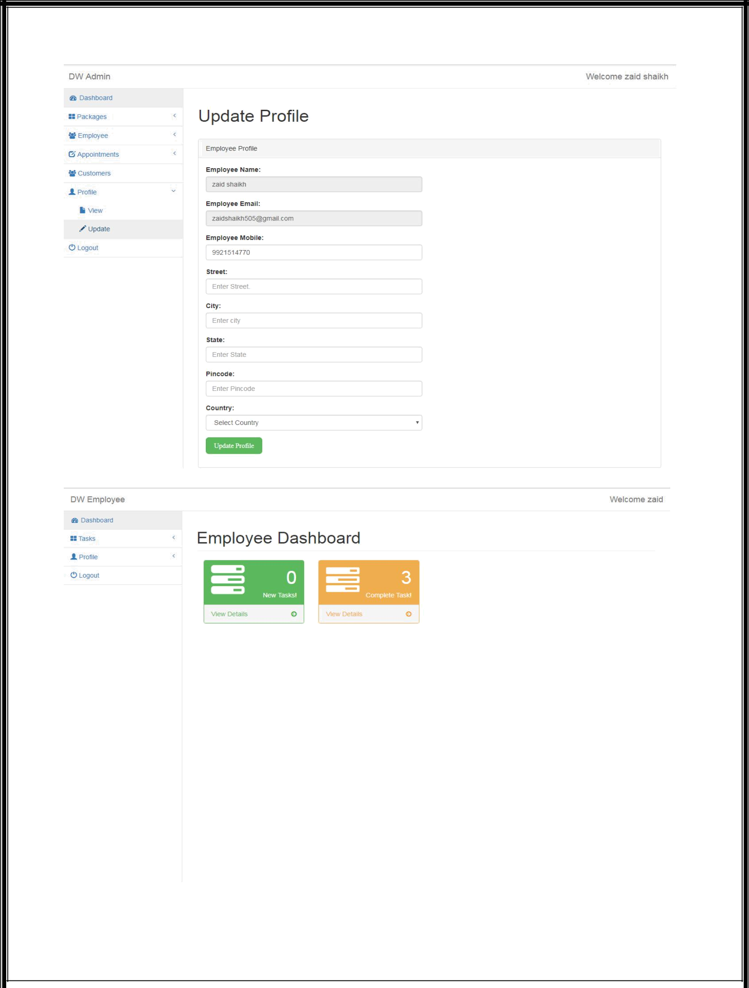

17

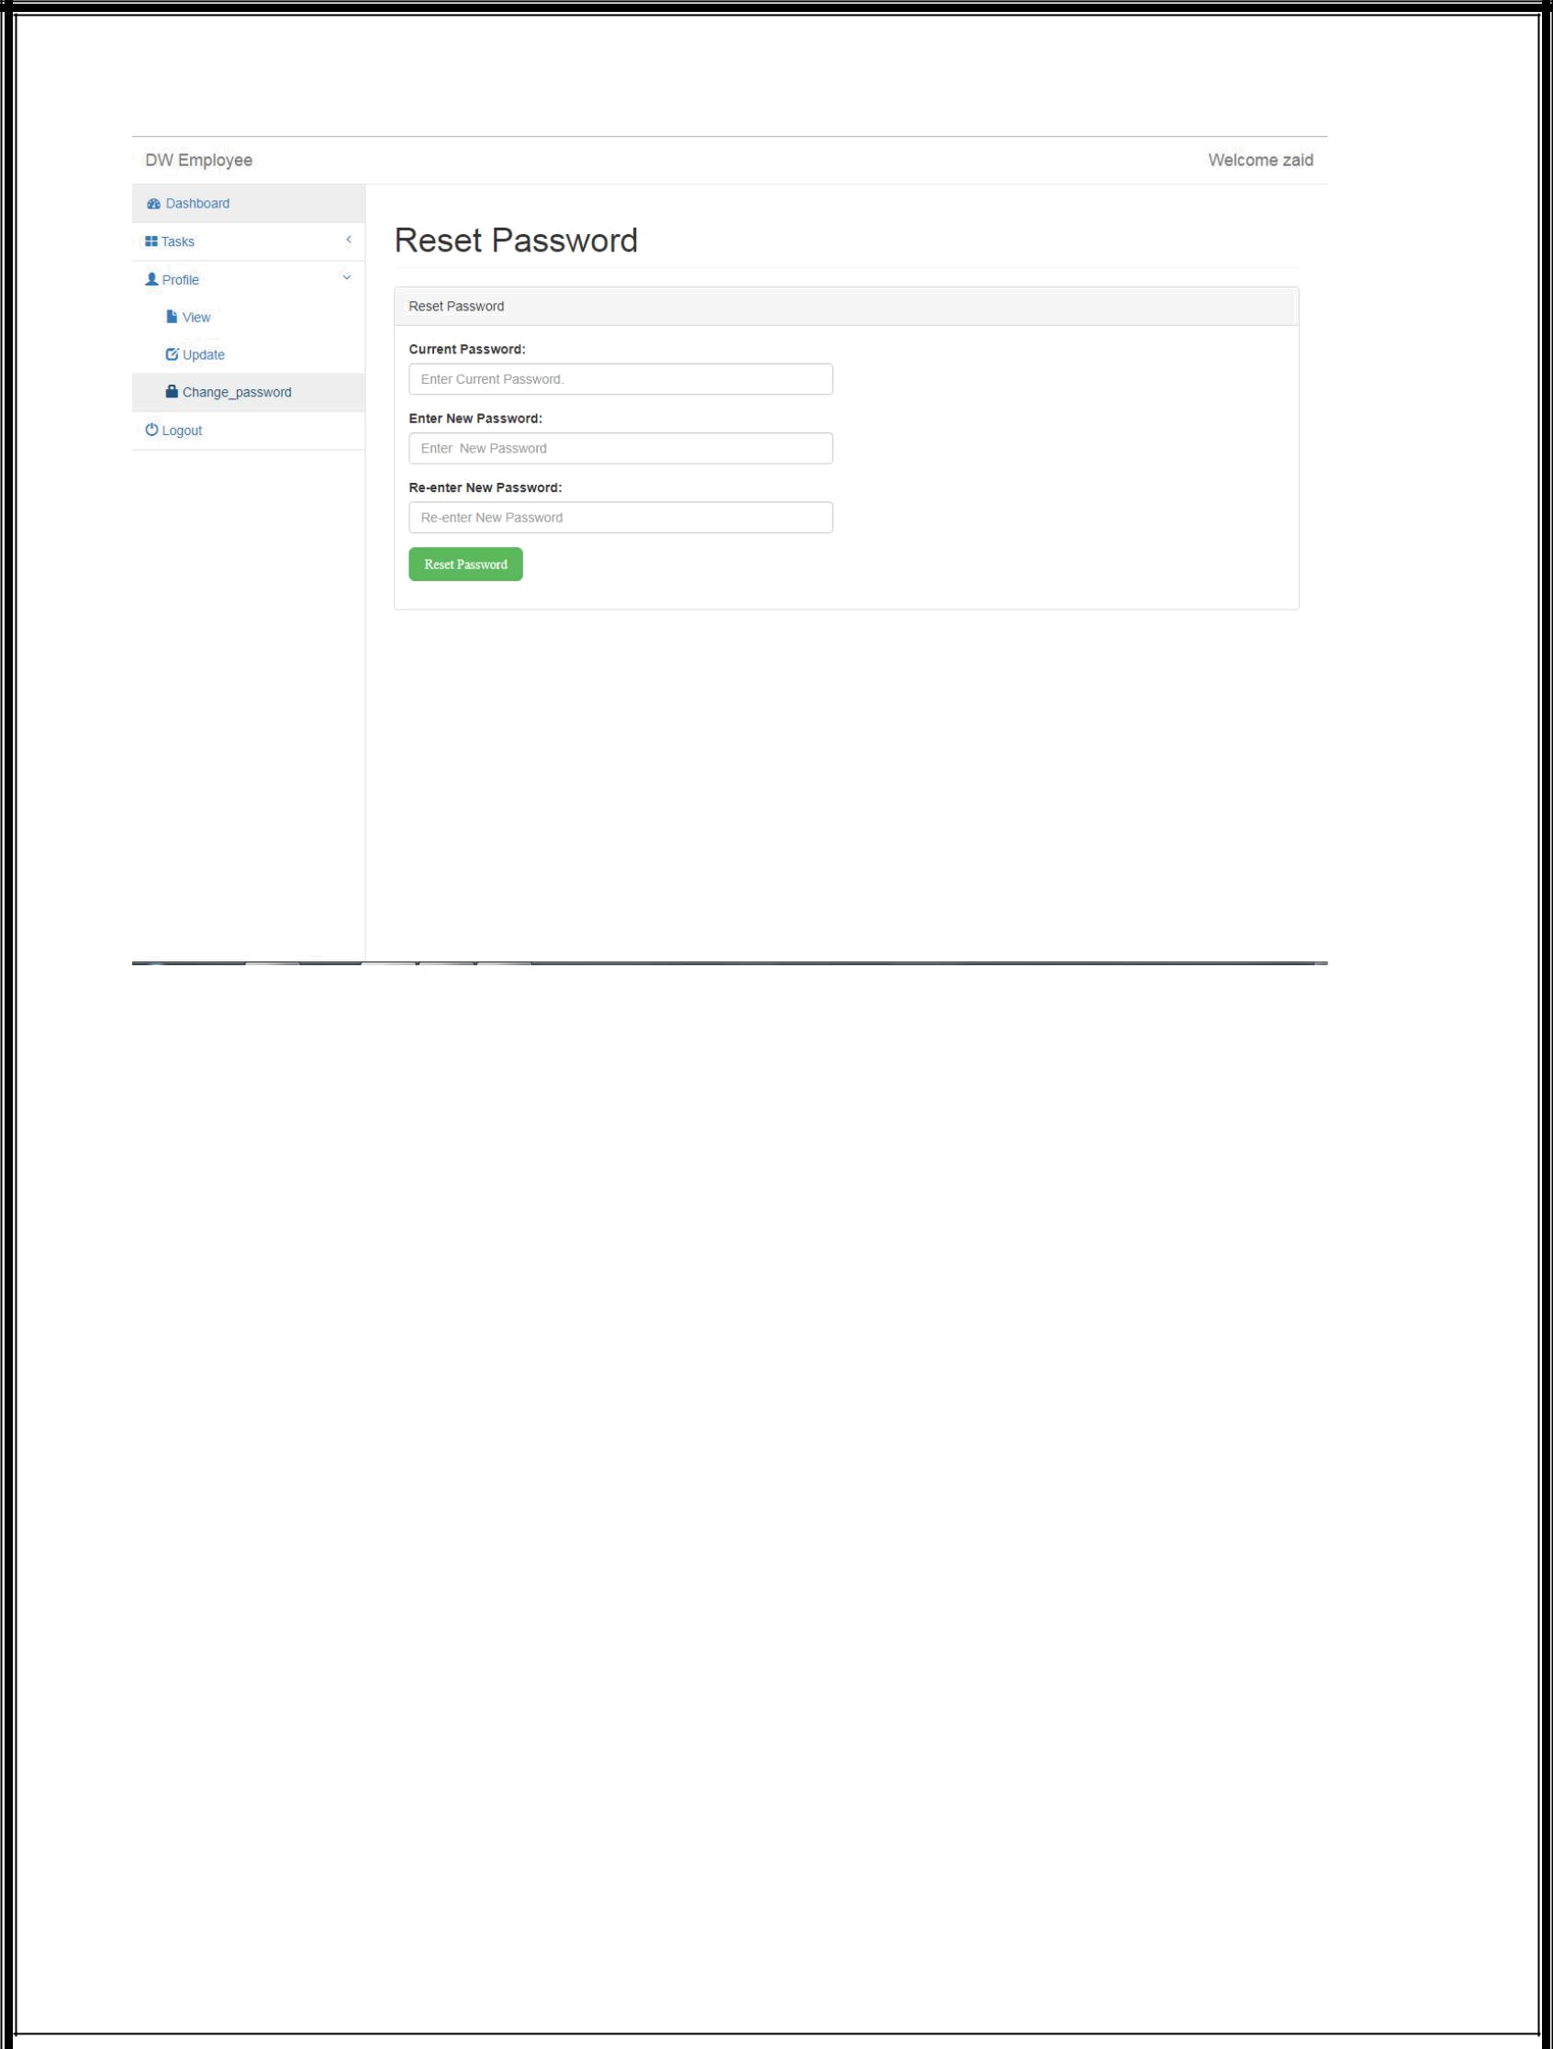

18

Table specifications:-

Table Name: CUSTOMER

COLUMN NAME | PK | Null? | DATA TYPE | DESCRIPTION
CUSTOMER_ID | 1 | N | SERIAL | USER_ID
CUSTOMER_NAME |  | N | VARCHAR | USER_NAME
CUSTOMER_MOBILE |  | N | VARCHAR | USER_MOBILE
CUSTOMER_PASSWORD |  | N | VARCHAR | USER_PASSWORD

Table Name: CUSTOMER_ADDRESS

COLUMN NAME | PK | Null? | DATA | DESCRIPTION
 |  |  | TYPE
CUSTOMER_ADDRESS_ID | 1 | N | SERIAL | CUSTOMER_ADDRESS_ID
CUSTOMER_STREET |  | N | VARCHAR | CUSTOMER_STREET
CUSTOMER_LANDMARK |  | N | VARCHAR | CUSTOMER_LANDMARK
CUSTOMER_STATE |  | N | VARCHAR | CUSTOMER_STATE
CUSTOMER_PINCODE |  | N | VARCHAR | CUSTOMER_PINCODE

19

Table Name: PACKAGE

COLUMN NAME | PK | Null? | DATA TYPE | DESCRIPTION
PACKAGE _ID | 1 | N | SERIAL | PACKAGE _ID
PACKAGE _NAME |  | N | VARCHAR | PACKAGE _NAME
PACKAGE _PRICE |  | N | INT | PACKAGE _PRICE
NO_OF_SERVIECES |  | N | INT | NO_OF_SERVIECES
PACKAGE_TYPE |  | N | VARCHAR | PACKAGE_TYPE

Table Name: PACKAGE_DETAILS

COLUMN NAME | PK | Null? | DATA TYPE | DESCRIPTION
PACKAGE | 1 | N | SERIAL | PACKAGE
_DETAILS_ID |  |  |  | _DETAILS_ID
PACKAGE _ID |  | N | INT | PACKAGE _ID
CUSTOMER_ID |  | N | INT | CUSTOMER_ID
PURCHASE_DATE |  | N | DATETIME | PURCHASE_DATE

20

Table Name: EMPLOYEE_SIGNUP

COLUMN NAME | PK | Null? | DATA | DESCRIPTION
 |  |  | TYPE
EMPLOYEE_ID | 1 | N | SERIAL | EMPLOYEE_ID
EMPLOYEE _NAME |  | N | VARCHAR | EMPLOYEE _NAME
EMPLOYEE_STATUS |  | N | VARCHAR | EMPLOYEE_STATUS
EMPLOYEE_TYPE |  | N | VARCHAR | EMPLOYEE_TYPE
EMPLOYEE_MAIL |  | N | VARCHAR | EMPLOYEE_MAIL
EMPLOYEE_MOBILE |  | N | VARCHAR | EMPLOYEE_MOBILE
EMPLOYEE_PASSWORD |  | N | VARCHAR | EMPLOYEE_PASSWORD
EMPLOYEE_STREET |  | N | VARCHAR | EMPLOYEE_STREET
EMPLOYEE_LANDMARK |  | N | VARCHAR | EMPLOYEE_LANDMARK
EMPLOYEE_PINCODE |  | N | VARCHAR | EMPLOYEE_PINCODE
EMPLOYEE_COUNTRY |  | N | VARCHAR | EMPLOYEE_COUNTRY

21

Table Name: APPOINTMENT

COLUMN NAME | PK | Null? | DATA | DESCRIPTION
 |  |  | TYPE
APPOINTMENT_ID | 1 | N | SERIAL | APPOINTMENT_ID
APPOINTMENT_DATE |  | N | VARCHAR | APPOINTMENT_DATE
APPOINTMENT_STATUS |  | N | VARCHAR | APPOINTMENT_STATUS
CAR_NO. |  | N | VARCHAR | CAR_NO
EMPLOYEE_ID |  | N | INT | EMPLOYEE_ID
COMPLETION_DATE |  | N | VARCHAR | COMPLETION_DATE
PACKAGE _DETAILS_ID |  | N | INT | PACKAGE _DETAILS_ID
CUSTOMER_ADDRESS_ID |  | N | INT | CUSTOMER_ADDRESS_ID

22

Drawbacks and Limitations:-

A car wash can be a good business for an entrepreneur with little previous business experience. As the number of cars on the road continues to increase the need for car wash businesses should also increase. Potential disadvantages to owning a car wash include that depending on your geographic area, the business can be seasonal. If you operate a full-service car wash, you will need to hire and manage a staff of employees. You will also have to deal with customers who are not satisfied with the finished product. If you're not mechanically inclined, you will need to hire a maintenance worker to tend to the machinery, which may break down during busy periods. Other factors to consider include your ability to manage your cash flow. A string of bad weather can put a damper on your business, so you need to handle your money wisely. The business typically requires long hours and physical labor, so a high energy level is also necessary.

The main drawback is that the system is stand alone that is the database need to reside on the local system it should have being a distributed pplication so it can access from a any network frameany terminal having centralised remote databse.

23

Proposed Enhancements

Linux is one of the fastest growing operating systems and slowly the use of linux will be much acquainted to the people, hence the system which is developed has a good future prospect.

Later we can develop a system which can have graphical user interface and advanced Facilities like That which will help user to use the system very efficiently.Currently the project can be enhanced to contain screens of more than onr cilent/server.

- Unlimited number of users.

- Integrate and automate your records.

- Get real time and uplated reports.

24

Bibliography:-

During development any project some good sourecs should be referred.During the development of our project we referred some useful books which are good sources of knowledge.

25

